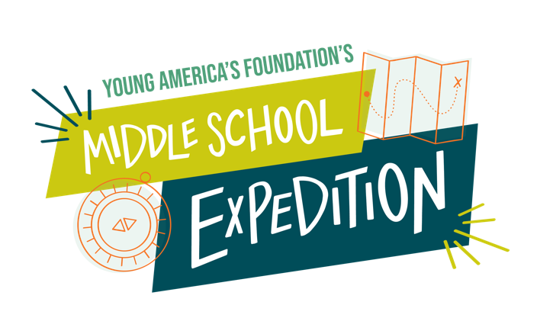
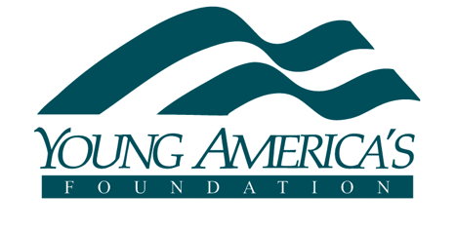

In Washington, D.C.
At the Museum of the Bible
May 9–10, 2025
Who can attend the Expedition?
Any students enrolled in middle school (grades 6-8) can attend this program.

When should I arrive?
Day One: You should arrive Friday, May 9, for check-in between 5:30 p.m. and 5:55 p.m. at the Museum of the Bible (400 4th St. SW, Washington, DC 20024). The program begins promptly at 6:00 p.m., so please be on time.

Day Two: You should arrive at the Museum of the Bible at 8:30 a.m. Parents will drop their students off.

What time does the Expedition end?
The Expedition ends Saturday, May 10, at 5:00 p.m., and students should depart from the Museum of the Bible. Parents may join the students for a special closing session on Saturday at 4:30 p.m. at the Museum of the Bible. Parent attendance for this session requires museum entrance. Discounted tickets will be available through YAF for all-day use.

What does the registration fee include?
The $50 registration fee includes Expedition tuition, materials, admission to the Museum of the Bible, transportation to the National Mall, Foundational Documents Tour, Friday dinner, and Saturday lunch for students.

What are the expectations of parents for the Expedition?
Parents are invited to the opening dinner on Friday and the special concluding session on Saturday at 4:30 p.m. Parents must RSVP for the dinner and the closing session, and further details will be emailed to students and parents in the weeks preceding the Expedition. The dinner is an additional $35 per adult and complimentary with RSVP for students. Museum tickets, requiring advance registration through YAF, are $8.00 per person for Saturday use only.
For more questions about this, please contact Tawny Kilpper at tkilpper@yaf.org.

Is tuition assistance available?
Tuition assistance may be available case-by-case for those with financial need. If you have a financial need, please email a brief essay (no more than one paragraph) to Tawny Kilpper at tkilpper@yaf.org with some language regarding your financial need and what you hope to gain by attending the Expedition.

Are travel scholarships available?
While travel assistance is never guaranteed, Young America’s Foundation will gladly consider all completed requests to alleviate the cost of student flights and hotel stays. Travel assistance may be available on a case-by-case basis for those with demonstrable financial need. Apply for travel assistance here.

Travel assistance requests are due prior to the event. Please note, travel assistance is not guaranteed and does not cover ground transportation, baggage fees, seat assignments, travel insurance. etc. Flights must allow for full-time attendance to be eligible for reimbursement.

If you have any questions regarding your travel assistance submission, please email travel@yaf.org.

Are hotel accommodations available?
Young America’s Foundation does not provide hotel accommodations for this program. Young America’s Foundation sometimes partners with a local hotel to offer parents of students attending our programs rooms at a discounted rate. Please email tkilpper@yaf.org to inquire about discounted rooms.

To which airport do I fly?
You should fly to Washington Reagan National (DCA). An alternate option is to arrive at Washington Dulles International Airport (IAD) and take the metro into the city, but this will add about an hour and a half to your arrival.

How will I get to and from the airport and the Expedition?
Young America’s Foundation will not provide transportation to/from the airport.

What is the dress code for this Expedition?
Dress for Friday is business. This means slacks, skirts or dresses, polo or button-up shirts, sweaters, etc. Jeans, shorts, and t-shirts are not acceptable attire. Dress for Saturday is casual but respectful. Jeans are acceptable if there are no holes or tears. Please wear comfortable shoes appropriate for walking. DC weather is unpredictable during late spring, so sunscreen and umbrellas are recommended.

What are the terms and conditions of the Expedition?

I am registering for myself, or on behalf of my minor child or ward (hereafter “child”), to attend a Young America’s Foundation’s (YAF) private event. I understand and agree that, as an express condition of participation and/or attendance in YAF’s event, I intend to be legally bound and will abide by the following terms & conditions.

A. Terms of Registration. All attendees must register themselves or their child and any guests they may be registering for using the real and true name for all parties and may be asked to present valid identification to verify the identity of the registrant and their guests. I understand and acknowledge that any actions intended to disrupt or undermine this YAF event will result in my or my child’s immediate ejection from the event. Disruptive activity includes, without limitation and in YAF’s sole determination, posting or sending inappropriate words, statements, or images, through social media or by and between event attendees. YAF reserves the right to pursue all appropriate civil & criminal remedies against disruptive attendees. Attendees removed for disruptive activity forfeit any registration fees and will be required to reimburse YAF at applicable actual costs of their attendance within ten (10) business days.

B. Acceptance & Attendance.
a. I understand that this event may have a limited amount of space and that my application may be subject to confirmation. I understand that all applications submitted before Dec 20, 2024, will receive a response regarding acceptance on Dec 20, 2024. Applicants who apply after Dec 20, 2024, will receive notice within two (2) weeks of their application submission. I understand that in the event I have not been accepted I will be refunded via my original payment method.
b. Participation in this YAF event is made possible through the generous financial support of YAF’s supporters nationwide. As such, I or my child agree to attend all sessions of the program. I understand that if I or my child fail to attend the entirety of YAF’s event without good cause, I agree to refund YAF the actual cost of attendance for the event, including hotel, food, transportation, and other costs incurred.
c. Acceptance and participation in this YAF event include reviewing and understanding the terms and conditions of YAF’s Responsibility Pledge, the terms of which are incorporated by reference. I understand that violation of the Responsibility Pledge may result in my removal or the removal of my child from the event, forfeiture of registration fees, and applicable reimbursement due to YAF.

C. Cancellation. Except in case of emergency, if accepted to attend YAF’s event, I must notify YAF by April 15, 2025, of my or my child’s inability to attend, or I may be charged $1,000 since it is too late to give my reserved space to another participant. I understand that the program fee is not refundable if I cancel my participation after April 15, 2025.

D. Policy Focused Event. YAF’s event is intended solely for the promotion of conservative ideas in accordance with YAF’s tax-exempt mission. No political activity, as defined by the Internal Revenue Service, is permitted at YAF’s event. No candidate stickers, pins, t-shirts, or other materials may be worn, displayed, or otherwise visible by members of the audience. I understand that attendees will not promote any other groups or organizations without express written permission from YAF.

E. Roommates & Lodging. If applicable, I understand that I or my child may be assigned roommates for the program. A preferred roommate of the same sex may be requested, but YAF is not obligated to honor that request. I agree to notify YAF staff immediately if a problem with a roommate arises during the event. I or my child further agree to abide by all applicable hotel rules, as well as any rules or instructions from YAF staff as deemed necessary, in YAF’s sole determination, during any overnight event stay.

F. Consideration. In consideration for participation in this event or program, the receipt and sufficiency of which consideration is acknowledged, I agree to release and forever discharge YAF, its officers, employees, and assigns from all manner of actions, legal causes of action, claims, and demands for or by reason of any damage, loss, or injury to person and property which has been or may be sustained as a result of my own or my child’s participation in this event or program.

Liability Release. I am fully aware that there are risks, foreseeable and unforeseeable, related to me or my child or ward attending this event or program, ranging from normal risks associated with any stay away from home, such as physical injury from a slip and fall or accident, food poisoning or allergic reactions, loss or damage to personal property, fires, disasters, terrorism or other incidents of violence, contraction of illness such as the flu, COVID-19, or legionnaire’s disease, which could result in a serious medical condition requiring treatment in a hospital or could possibly lead to death.

For my own benefit or on behalf of my child or ward, our heirs, successors, and assigns, I knowingly and freely assume all such risks, both known and unknown, relating to participation in this event or program, and I hereby forever release, waive, relinquish, and discharge YAF, its officers, employees, and assigns from any and all claims, demands, liabilities, rights, damages, expenses, and causes of action of whatever kind or nature, and other losses of any kind, whether known or unknown, foreseen or unforeseen, and I further promise not to sue YAF for any personal injury, disability, property damage or theft, or death which may result from participation in this program. These terms and conditions shall be construed under Tennessee law and should be interpreted by any court of competent jurisdiction to provide a release and waiver to the maximum extent permissible.

G. Assumption of Risk. I assume all risks and hazards incidental to participation in the function mentioned above, including transportation to and from such activities, and do hereby release and waive all claims against YAF, its directors, officers, staff, employees, volunteers, representatives, agents, and speakers whether they be foreseen or unforeseen at the time this waiver is signed. I UNDERSTAND THAT IT IS MY SOLE RESPONSIBILITY TO AVOID EXPOSING MYSELF OR MY CHILD TO FOODS THAT WE MAY BE ALLERGIC TO AND TO TAKE ALL NECESSARY PRECAUTIONS RELATING TO POTENTIAL ALLERGIES, INCLUDING HAVING ANY MEDICATION SUCH AS AN EPINEPHRINE PEN (“EPIPEN”) ON MY OR MY CHILD’S PERSON AT ALL TIMES AND NOTIFYING YOUNG AMERICA’S FOUNDATION STAFF OF CONCERNS. I understand that YAF makes no promises or guarantees that an accommodation will be made for my or my child’s allergy, even after notifying YAF of said allergy. As such, I recognize that if I or my child consumes food or beverage at a YAF event, I assume the risk.

H. Emergency Medical Treatment Consent/ Property Damage. I grant permission for emergency medical treatment to be performed upon me or my child in case of sickness or injury and have indicated any special medical needs or allergies in the space provided below. All expenses incident to hospital care shall be my responsibility. I also accept responsibility for any property damage to the program facilities that I or my child may cause.

I. Consent and Release for Use of Likeness. YAF uses real photos, videos, and quotes from students for promotional purposes. By attending this YAF event on your own behalf or on behalf of your child, you irrevocably consent and authorize YAF and its affiliates, employees, related companies, and contractors, to record, film, photograph, broadcast, or otherwise capture during the event and related events your likeness, image, voice, or any other indicia of identity in any media whatsoever and to distribute, use, broadcast, or disseminate into perpetuity such media for any purpose whatsoever without any further approval from you or any compensation of any kind to you. The images in all media will constitute YAF’s sole property, and YAF will have the right to use your likeness, image, voice, or other indicia of identity, including, but not limited to, the right to produce, publicly perform, transmit, exhibit, publicly display, print, reproduce, televise, broadcast, transfer, modify, distribute, create derivative works of, and otherwise use for any lawful purpose, in whole or in part, in any location throughout the world through any means or medium or format without limitation, any Subject Matter, all without prior inspection or further consent or approval by the undersigned of the finished product(s) or of such use, together with irrevocable, perpetual, worldwide and royalty-free rights, title and interest in and to any and all results and proceeds from any such use.

J. Exclusive Broadcast Rights. You further agree that you will not record, reproduce, or transmit from the place of performance, in any manner or by any means whatsoever, any portion of, or the entirety of, any YAF event in the absence of the specific written permission of YAF. YAF retains the exclusive copyright to all materials that may be distributed at the event, unless otherwise noted, and all video or audio recordings of all YAF events.

K. Data Usage. By sharing your information with YAF, you agree that we may use your information to contact you about this event and other activities, such as educational materials or opportunities to attend future events, as disclosed to you at the point of collection, or in any other manner that advances our educational purposes. This includes, without limitation, adding your email address to receive YAF emails and receipt of telephone calls and text messages to your cell phone. You affirm that the cell phone number provided at registration is your own or that of your minor child, and that YAF may call and/or send text messages to this phone number to provide information regarding your application or registration for this event, as well as future YAF events and programming. You understand that message and data rates may apply to any such messages. We may share or transfer your information with our affiliates and any other organizations or entities for similar purposes.

L. Severability. If any provision of this waiver is held to be invalid or unenforceable, that provision will be eliminated or limited to the minimum extent possible, and the remainder of the waiver will have full force and effect.

M. Understanding and Acceptance. By including my name on this form and allowing my child to participate in this program, I confirm that I understand and have had a full opportunity to review these terms and conditions. I have had the opportunity to have these terms and conditions reviewed by a legal counsel of my choosing. In the event of any dispute between the Parties regarding any ambiguity or inconsistency in this terms and conditions, the adjudicating body will use a neutral construction not favouring either Party. I understand and agree that these terms and conditions constitute the full entire agreement between myself and YAF and supersede any prior oral or written understanding or agreement. No modifications, alterations, or amendments may be made to the terms and conditions unless done in writing and agreed to by both parties. I accept these terms freely, I declare my intention to bound by the terms, and I acknowledge it shall be construed broadly to provide a full release and release and waiver to the maximum extent permissible under applicable law.

